Monthly NEWSLETTER

march 2018
La Costa Hills HOA
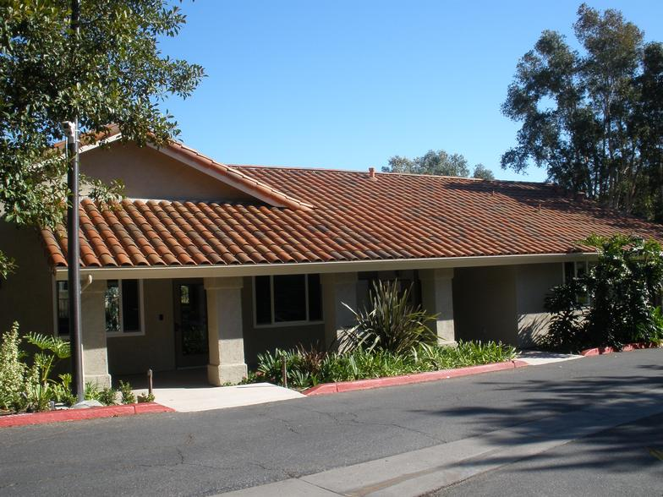

Upcoming Events

April 17
HOA Meeting – 5:00pm
At the Clubhouse

Important Announcements

PLEASE INFORM MANAGEMENT OF ANY REPAIRS ITEMS NEEDED
All Maintenance issues can be reported by email to:
LucasKoch@ebmc.com

You may also report any issues to:
mckenziemurrey@ebmc.com or by mail to La Costa Hills HOA
16935 West Bernardo Drive, Suite 250, San Diego, CA 92127
Accounting Questions should be referred to JodyKoch@ebmc.com

HOA Website:
www.lacostahillshoa.com
The website is updated and will remain current.

The website financial information has been changed.
The current password is:
lchfinancials

c/o Eugene Burger Management Corp., mckenziemurrey@ebmc.com
www.lacostahillshoa.com T: #760-431-5422 ext206 (McKenzie)

NEW INFORMATION - PREVENTATIVE MAINTENANCE
La Costa Hills HOA was built in 1989 which means our pipes are 28 years old. We have had a variety of pin hole leaks around the community and we needed to do something before things got worse and buildings were damaged. Luckily there is a solution. Before you read below – and before you call management upset – please take the time to go to our website and look in the Documents section for the document PHOSPHATES to better understand what we have chosen to do.
After the boilers are installed we will have completely safe Phosphate Treatment done to our water system. This is an FDA approved, odorless and tasteless treatment which only adheres to metal pipes. The phosphates will adhere to the copper pipes and create a safe protective barrier so that any pitting in the pipes are covered and we should have far less leaks. The phosphate will not stick to PEX or PVC. The company will monitor our water monthly and keep our levels safe and effective.
MESSAGE FROM THE BOARD
We have enjoyed serving our community the last few years. We feel that we are making great strides and appreciate the attendance and input at meetings. We also appreciate those who are not on the Board taking time to assist us with special projects and sending information in for review. Please continue to work together to make La Costa Hills the best HOA we can make it!
WEBSITE
Samantha is maintaining our www.lacostahillshoa.com website regularly and would like membership to utilize it. Please check it out!

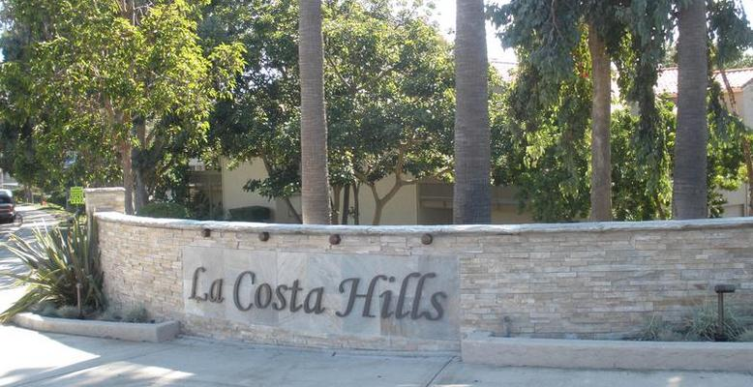

In the Community

Committees
Finance
Maintenance
Landscape
Parking

YOUR BOARD
Samantha Easton– PRESIDENT
Vladimir Pozdnyakov-
TREASUER
Dianne Fletcher VP/-SECRETARY

La Costa Hills is a great community to live in as it is located in one of the most beautiful and progressive communities in North County.
Located near excellent schools and convenient walkability to La Costa Town Square.

Our community cannot do anything but grow in value as long as we value what we have!

NOISE
We all know that noise travels in the community and sometimes between the walls and floors. Please be considerate of everyone and keep noise levels to a minimum after 9pm and before 7am. This includes televisions, video gaming, loud music, dog barking, car engines, etc.
ROOFS AND GUTTERS
Gutter cleaning has been pushed back due to problems with our facia wood. We will need to replace some wood before cleaning and re-attaching some gutters. Please have patience and understand that we are working on it. If it rains and you see a stain – call it in!
large item pick up info
Each unit in our community is entitled to have 3 large item pick-ups per year up to 5 items on each pick up. So we have 2,640 pick-ups free to the HOA. In order to utilize this saving opportunity the residents should call (800) 596-7444 and reference commercial account # 15062789 to schedule a pick up. The call needs to be made the day before a normal pickup day (MWF).
GATE REMOTES
The gate is opening randomly and we believe it is because someone has a stuck remote. There is nothing wrong with the gate so please make sure your remote button is not stuck open. This can happen if you have your remote on your sun visor and it gets pressed in by accident. As a reminder please try not to leave your gate remotes inside your vehicles.
soil erosion
We continue to create retaining walls in the community. Please report soil erosion to management so that we can save our soil!
settlement cracks
Settlement is a normal occurrence in buildings. If you are unsure what is your responsibility in the community, there is a maintenance matrix at the end of the CC&Rs (found on website). Most cracks seen by the board are normal settling. We are currently working on developing a standard for when the cracks will become the responsibility of the HOA to repair and that will be published as soon as possible.

